Year 8 Earth and Beyond Quiz 1

Name: ____________________________ Mark: _______/15

- Label the layers of the Earth on the following diagram.
(4 marks)
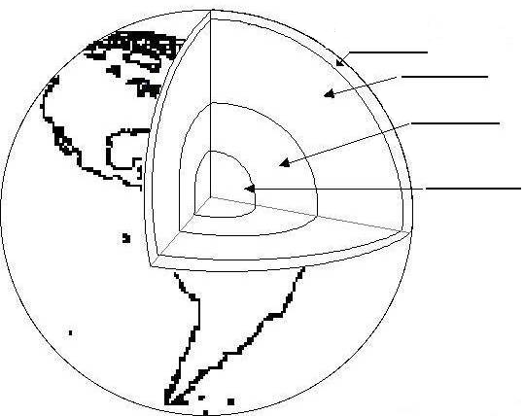

- Write the term that corresponds to each definition below
(4 marks)

___________________ A 2260km layer of very dense liquid at high temperature.

___________________ A very dense solid layer which behaves like a fluid

___________________ A thin outer layer about 100 kilometres thick which moves in sections called plates

___________________ A solid mass about 1220 kilometres thick. It is kept solid by the tremendous pressure that exists at this depth.
- What does the term ‘Plate Tectonics’ mean?
(2 marks)

- What causes the crustal plates to move?
(2 marks)

- Give three examples of evidence scientists have that the continents are drifting apart.
(3 marks)

